**Project Title:** **Rise of Self-Learning in Bangladesh: The Role of AI   
 Tools and EdTech Platforms  
Name**:SyedAhanaf Chowdhury Auditta  
Department OF Computer Sceince.

This project examines the impact of AI tools and EdTech platforms on self-learning among Bangladeshi students. Traditional education methods often hinder self-directed learning, but advancements in technology now offer accessible, time-saving, and personalized solutions. Using survey data, the study analyzes the frequency of tool usage and perceived benefits through statistical techniques like skewness and kurtosis. Results highlight varied adaptation rates, with tools like ChatGPT showing positive skewness and Duolingo achieving balanced usage. The findings underscore the potential of AI and EdTech to transform education in Bangladesh, advocating for further integration to enhance self-learning experiences for students.

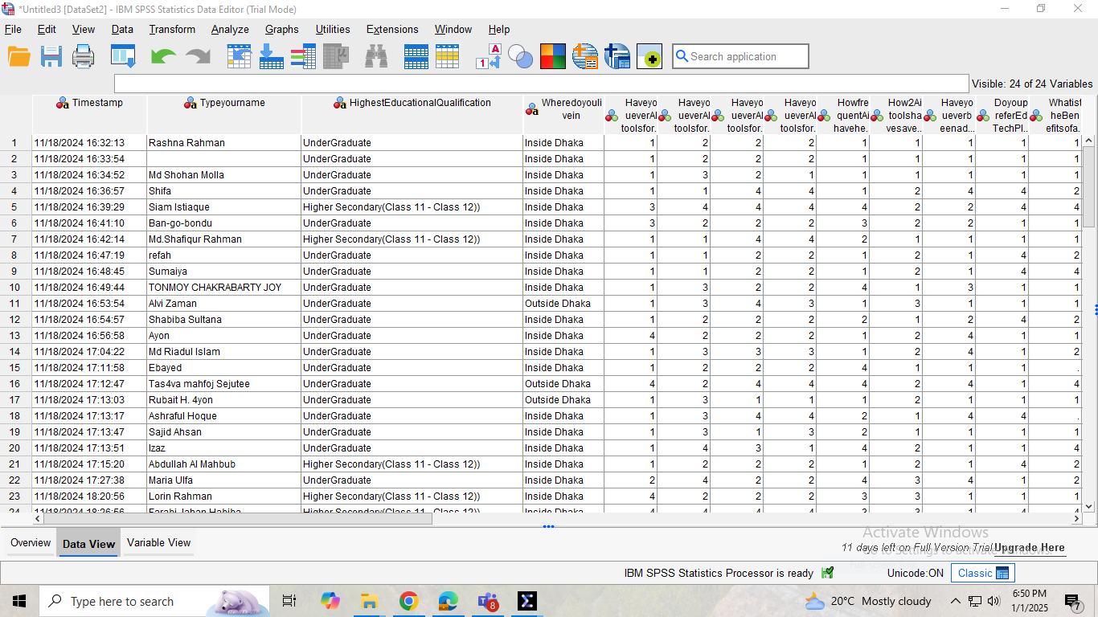  
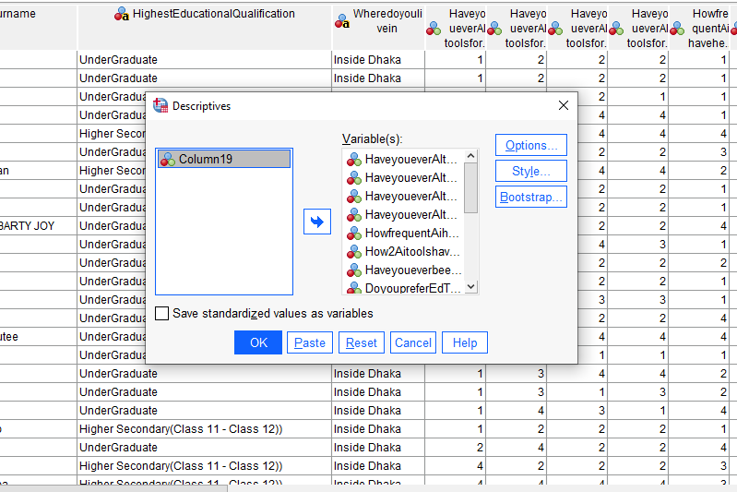

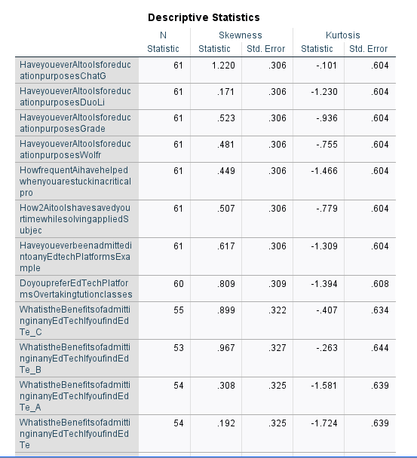  
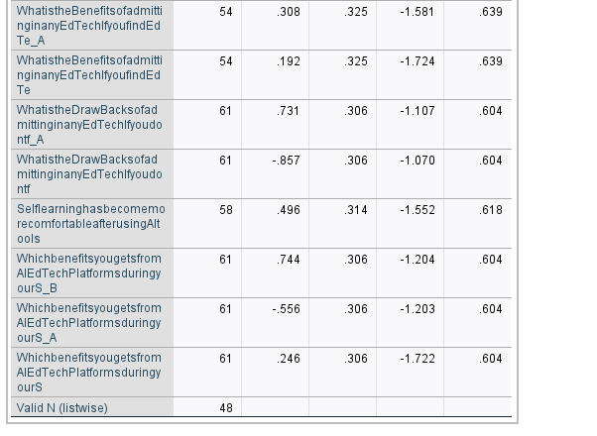  
Result:  
This dataset contains information on frequency of usage and benefits AI toolsand EdTech platforms Enrollment. The analysis with statistical techniques to explain the gathered data .The Skewness analysis represents the frequency of AI tools usage and Edtech solutions and Kurtosis represents the benefits from using AI tools and Edtech solutions. AI tools usage varied among peoples. From the dataset ChatGPT usage shows a positive skewness reflecting uneven adaptation, while Duolingo and Grade scope usage was balanced. In terms of kurtosis, it got moderate highlights because time saving benefits shows moderate kurtosis and suggesting agreements show diverse response.